1. **What is CI/CD Pipeline**?
2. **CI**: Continuous Integration.  
   **CD**: Continuous Delivery/Deployment.  
   Sometimes Delivery or Deployment but prefer Delivery but depending on context also Deployment.
3. **What is pipeline**?
   1. Pipeline means what is the sequence of steps when we do a task.
4. **CI/CD**:
   1. It is not a tool like we have git, maven, ansible etc.
   2. It is a **methodology**.   
      So, CI/CD is a way to execute a process.
   3. It is a **methodology** **for SDLC** (Software Development Life Cycle)
5. 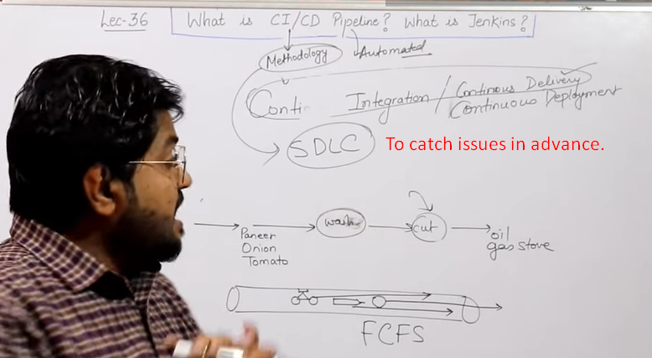

Let’s study the issues we faced before using CI/CD Pipeline.

1. **Before Continuous Delivery:**
   1. 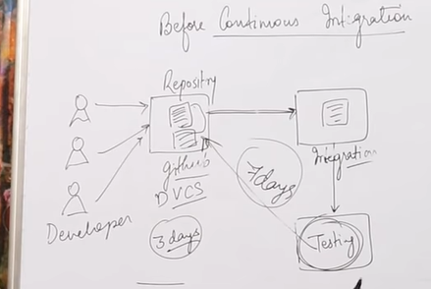All code is written and stored into repo.   
      Then code is integrated.   
      Then integrated code is tested and suppose, we found an error during testing.  
      Now the developers had already shifted to some other tasks 7 days before when test was executed.  
      Now to come back and remind everything back is difficult for developers. Second they are working on a different task now.  
      **Solution**: Continuous Integration.
2. **Continuous Integration**:
   1. Developers push codes in chunks as per Sprint.
   2. Immediately code is integrated and tested and on error, email is sent to the developer.
   3. The developer tries to resolve the error/bugs immediately.  
      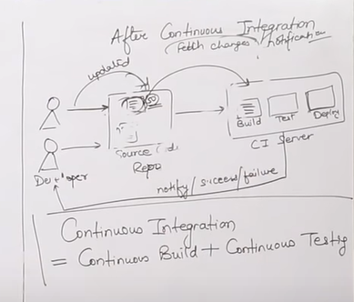
3. 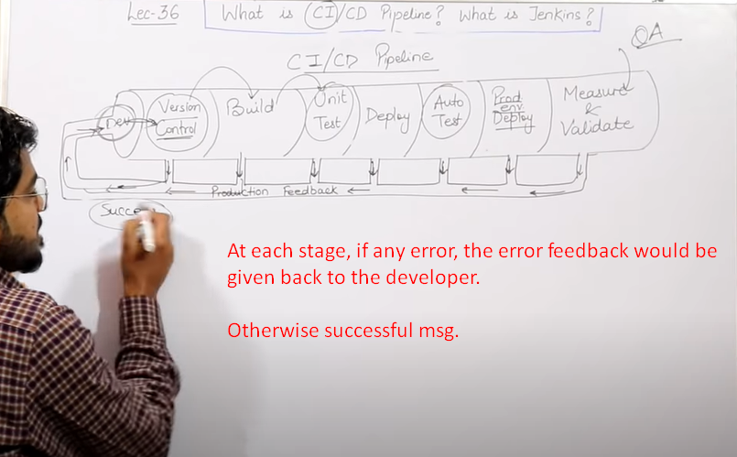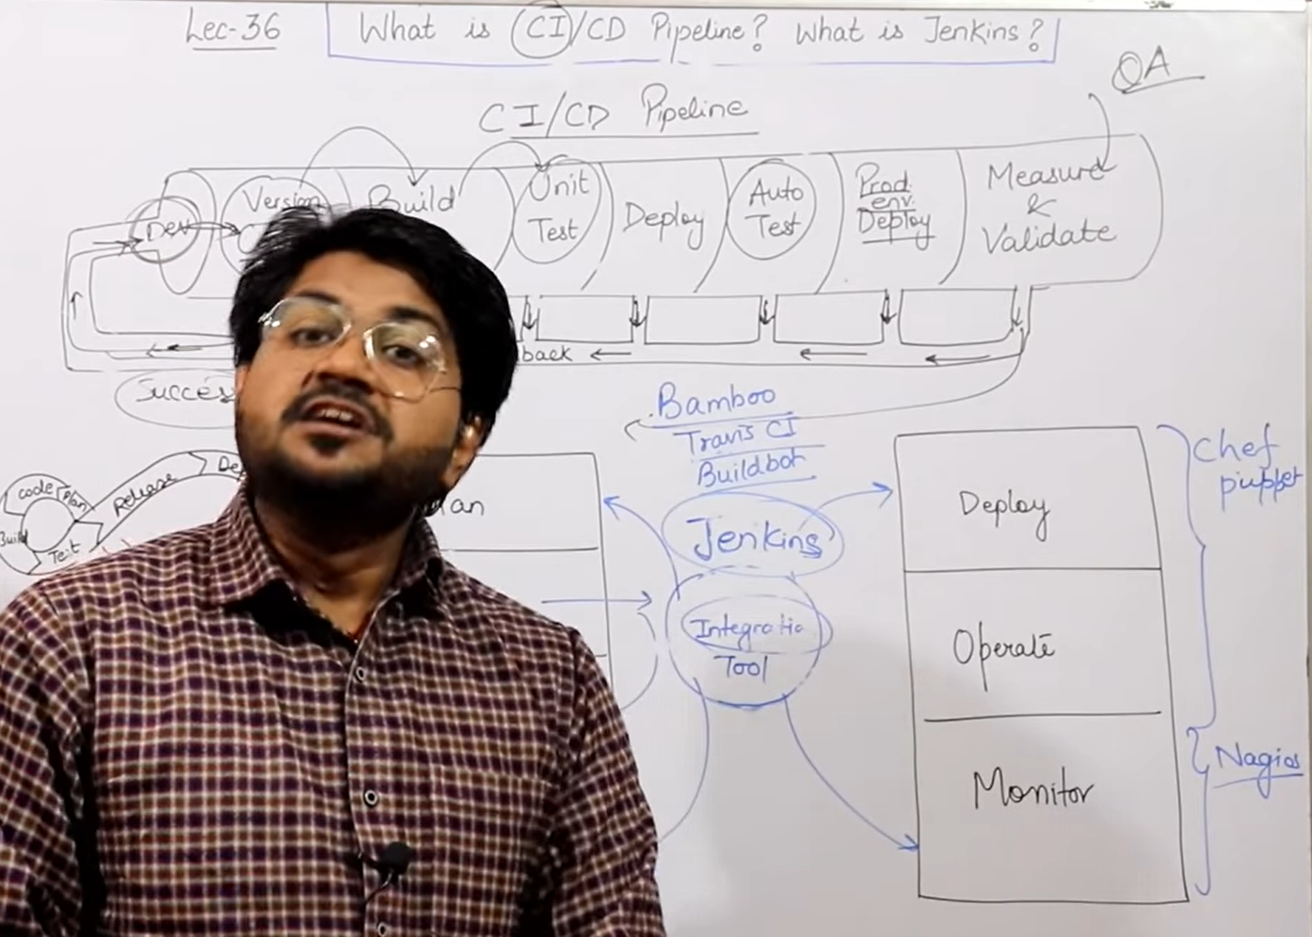
4. **Chef, Puppet**: To deploy the built code on different machines.
5. **Jenkin:**
   1. It is CI (Continuous Integration) tool.
   2. **Other tools**:
      1. Bamboo, Trans CI, Buildbot.
   3. But jenkin is open source whereas others are paid.
   4. It supports lots of plugins.
   5. Jenkin is not only a tool but a framework.
6. 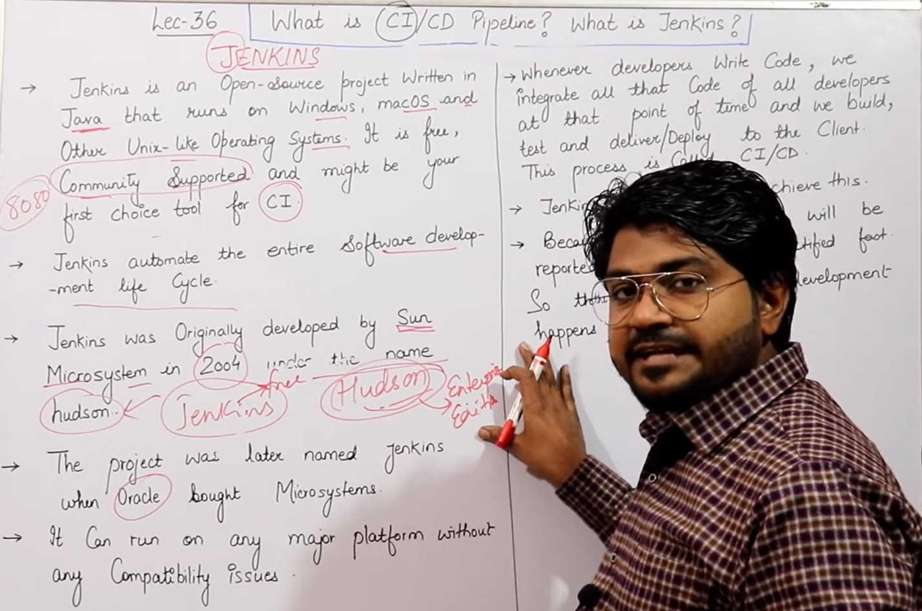
7. 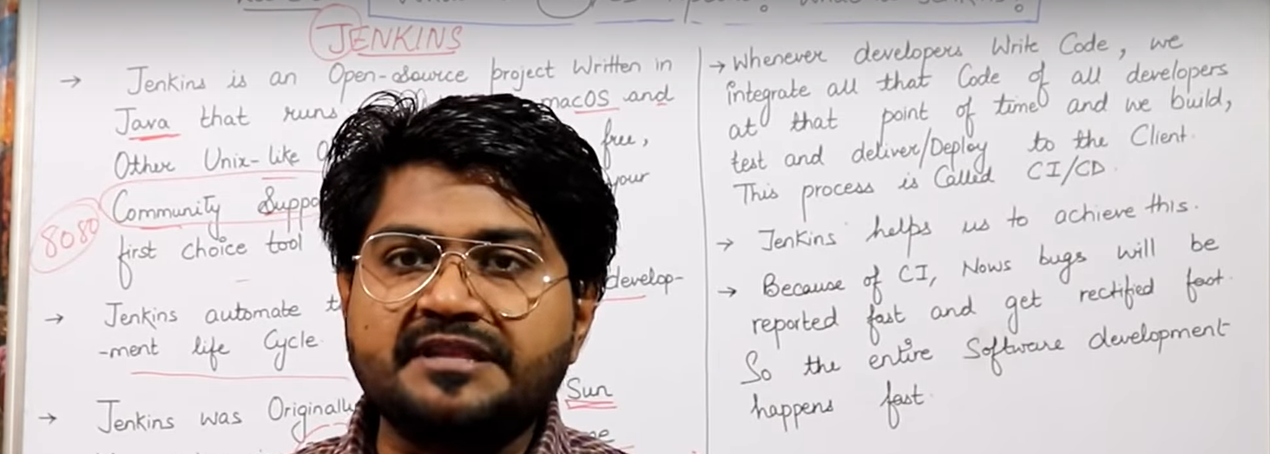

Workflow of Jenkins

1. **Workflow**:
   1. **Developer** pushes the code onto **Github**.
   2. **Jenkin** would pull the code from Github and makes the **maven** build the code and for example creates a jar file.
   3. **Jenkin** takes the built-code and sends to **selenium** to test it.
   4. **Jenkin** then takes code from selenium and sends to for example **checkstyle** tool for QA.
   5. **Jenkin** then takes the code from checkstyle and now it has two paths.
      1. **Deployment:**
      2. **Delivery:**

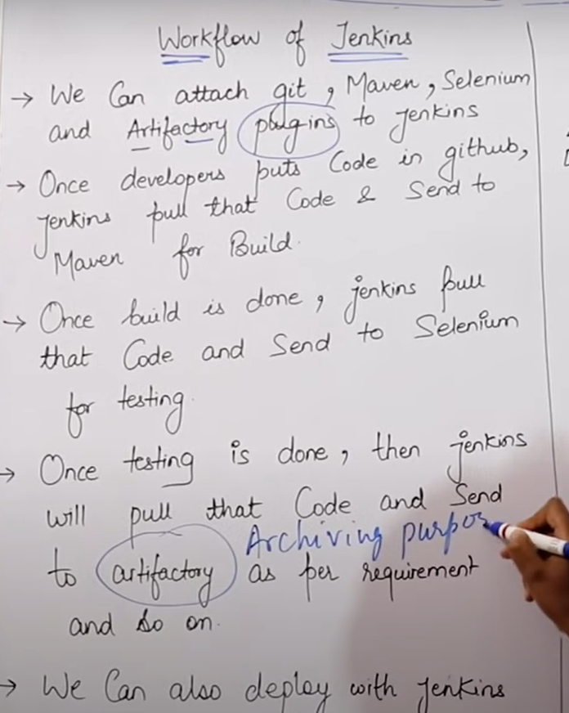

1. **Plugins**:
   1. For each stage, we have different plug-ins in Jenkins.
   2. **For example**:
   3. For github, there is a plugin.

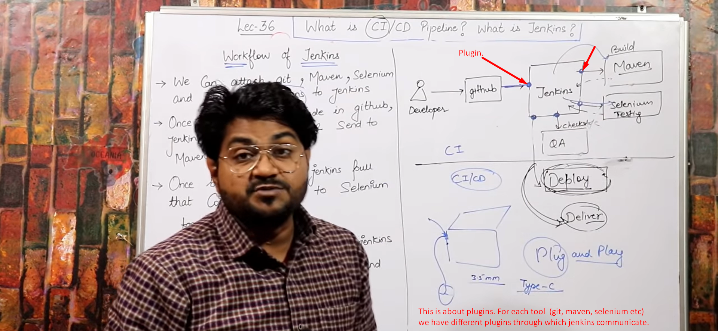

1. **Difference** b/w Artifactory vs Github:
   1. **Github**: Containing code on which we’re working.
   2. **Artifactory**: Containing final & ready code.

Advantages of Jenkins

1. 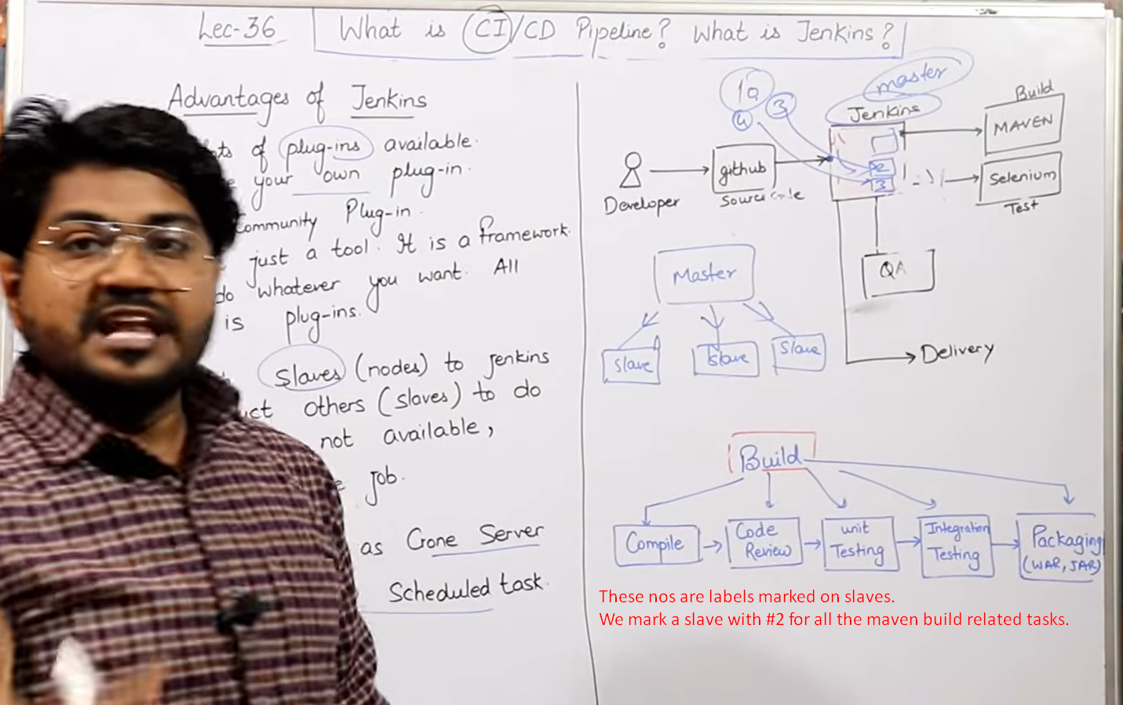
2. 